# Assignment-2

**Data Warehousing and Business Intelligence**

**Professor: Vincent Lattuada**

**NAME: UTKARSH UTKARSH**

**NU ID : 001216142**

**Question 1**

1. (5 pts) Export the HumanResources.Employee table from AdventureWorks.  If you use the wizard to learn that is fine but you must create a SSIS package in the SQL Server Data Tools / Visual studio environment.

Step 1: Data Flow Task

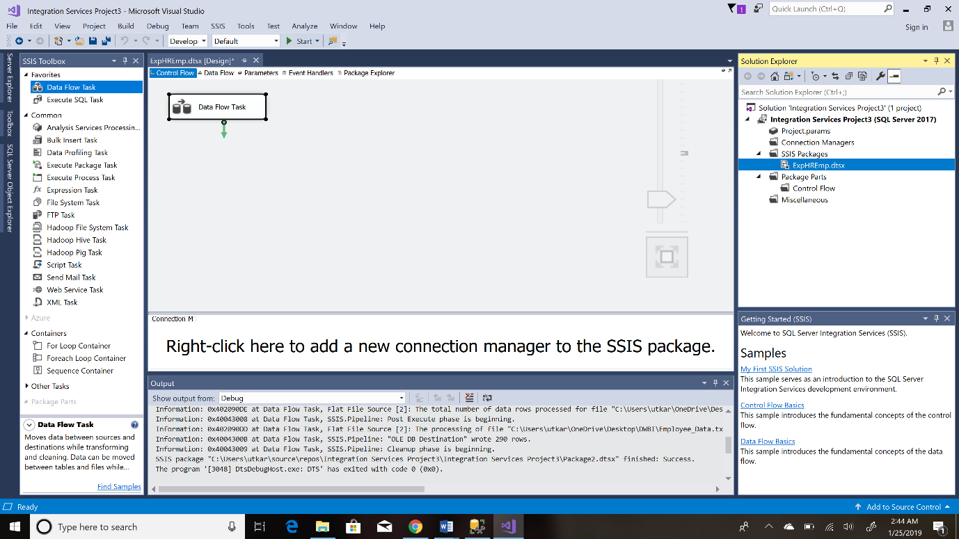

Step 2: OLEDB Source (Acts as a source for all the RDBMS Database)

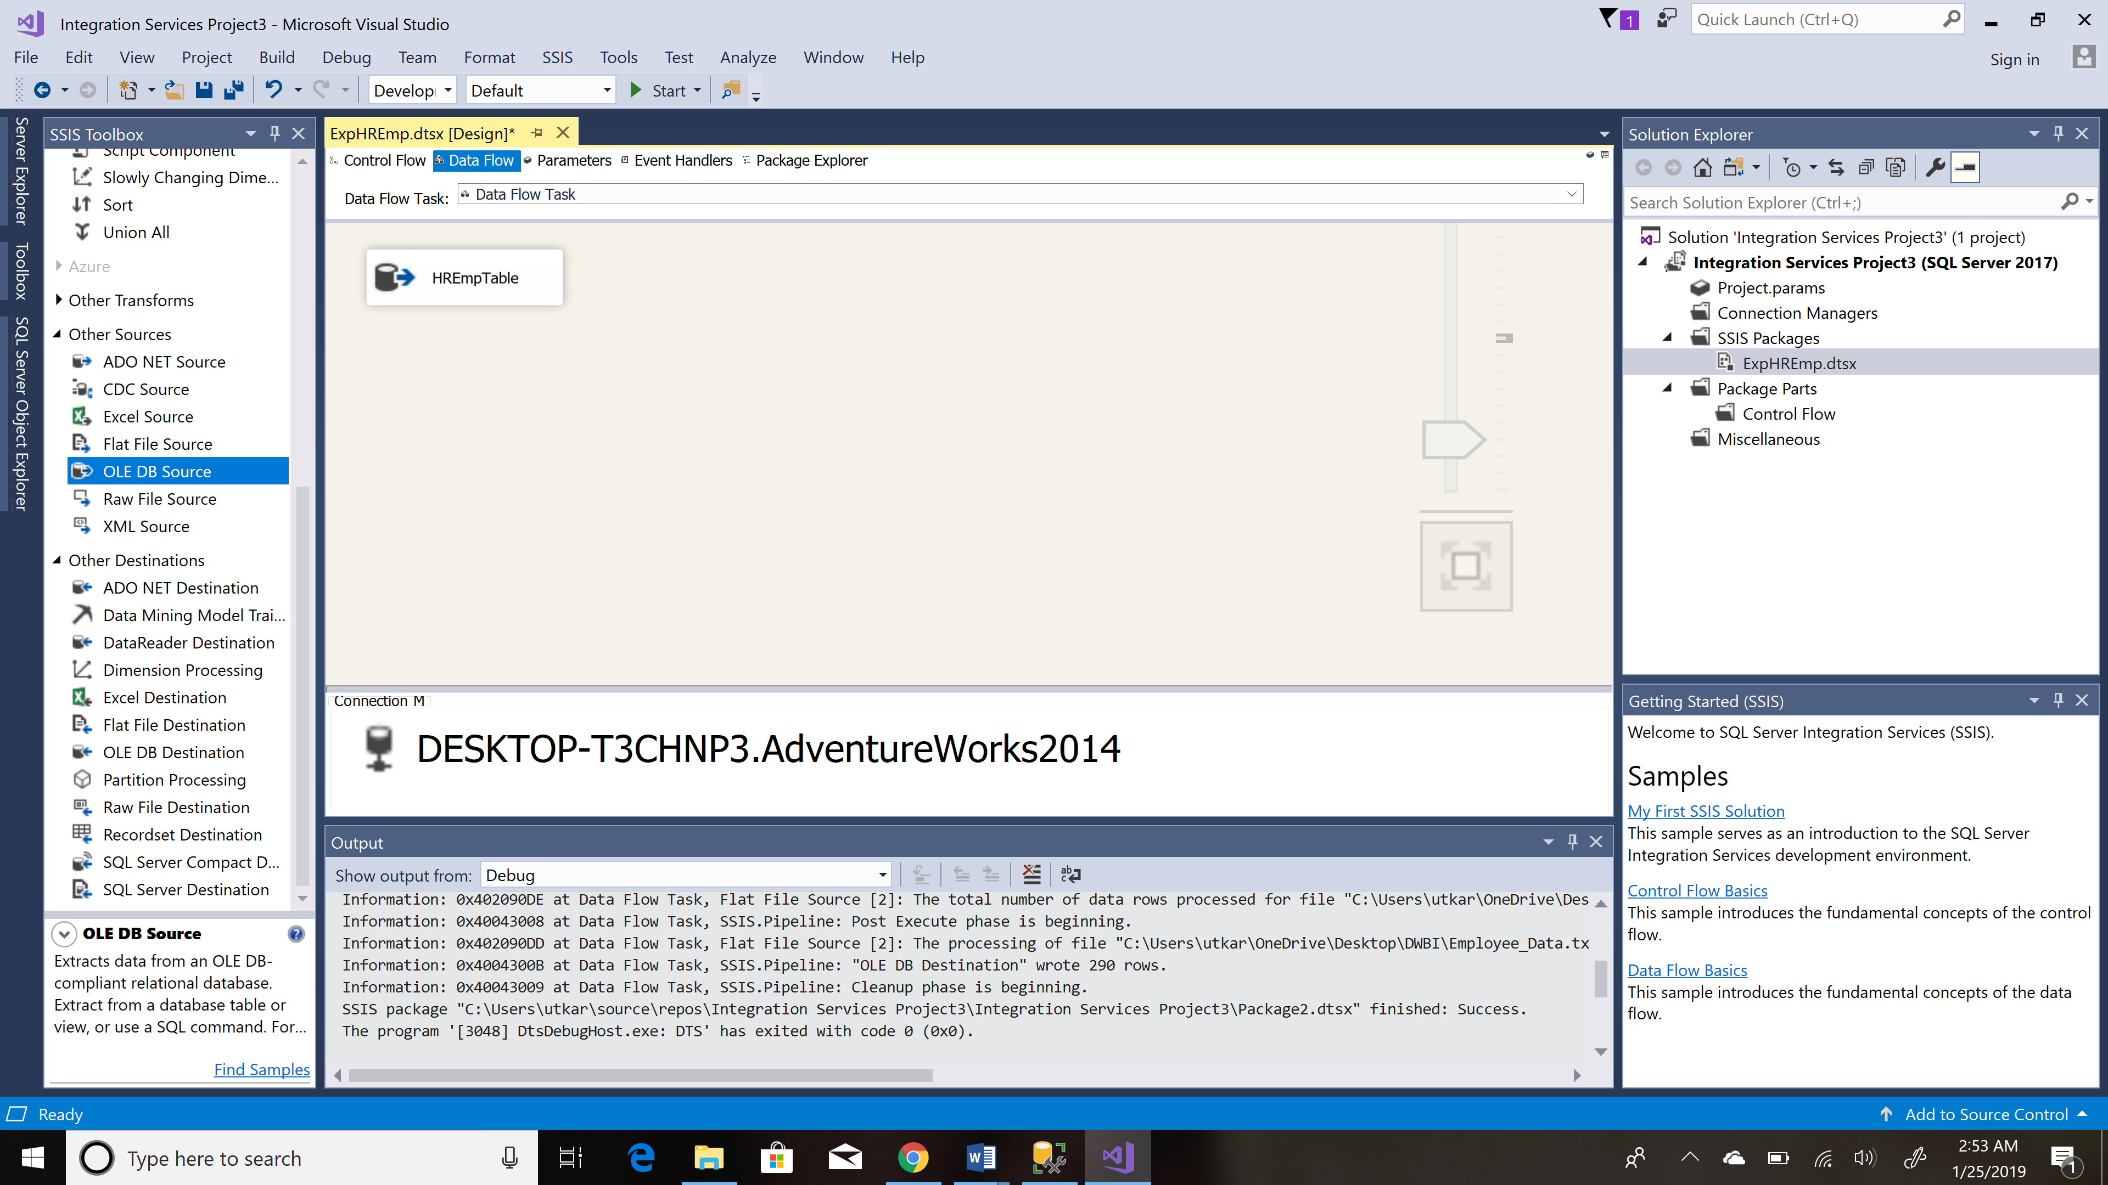

Step 3: Flat File Destination (Connecting,Editing and Mapping the Destination File)

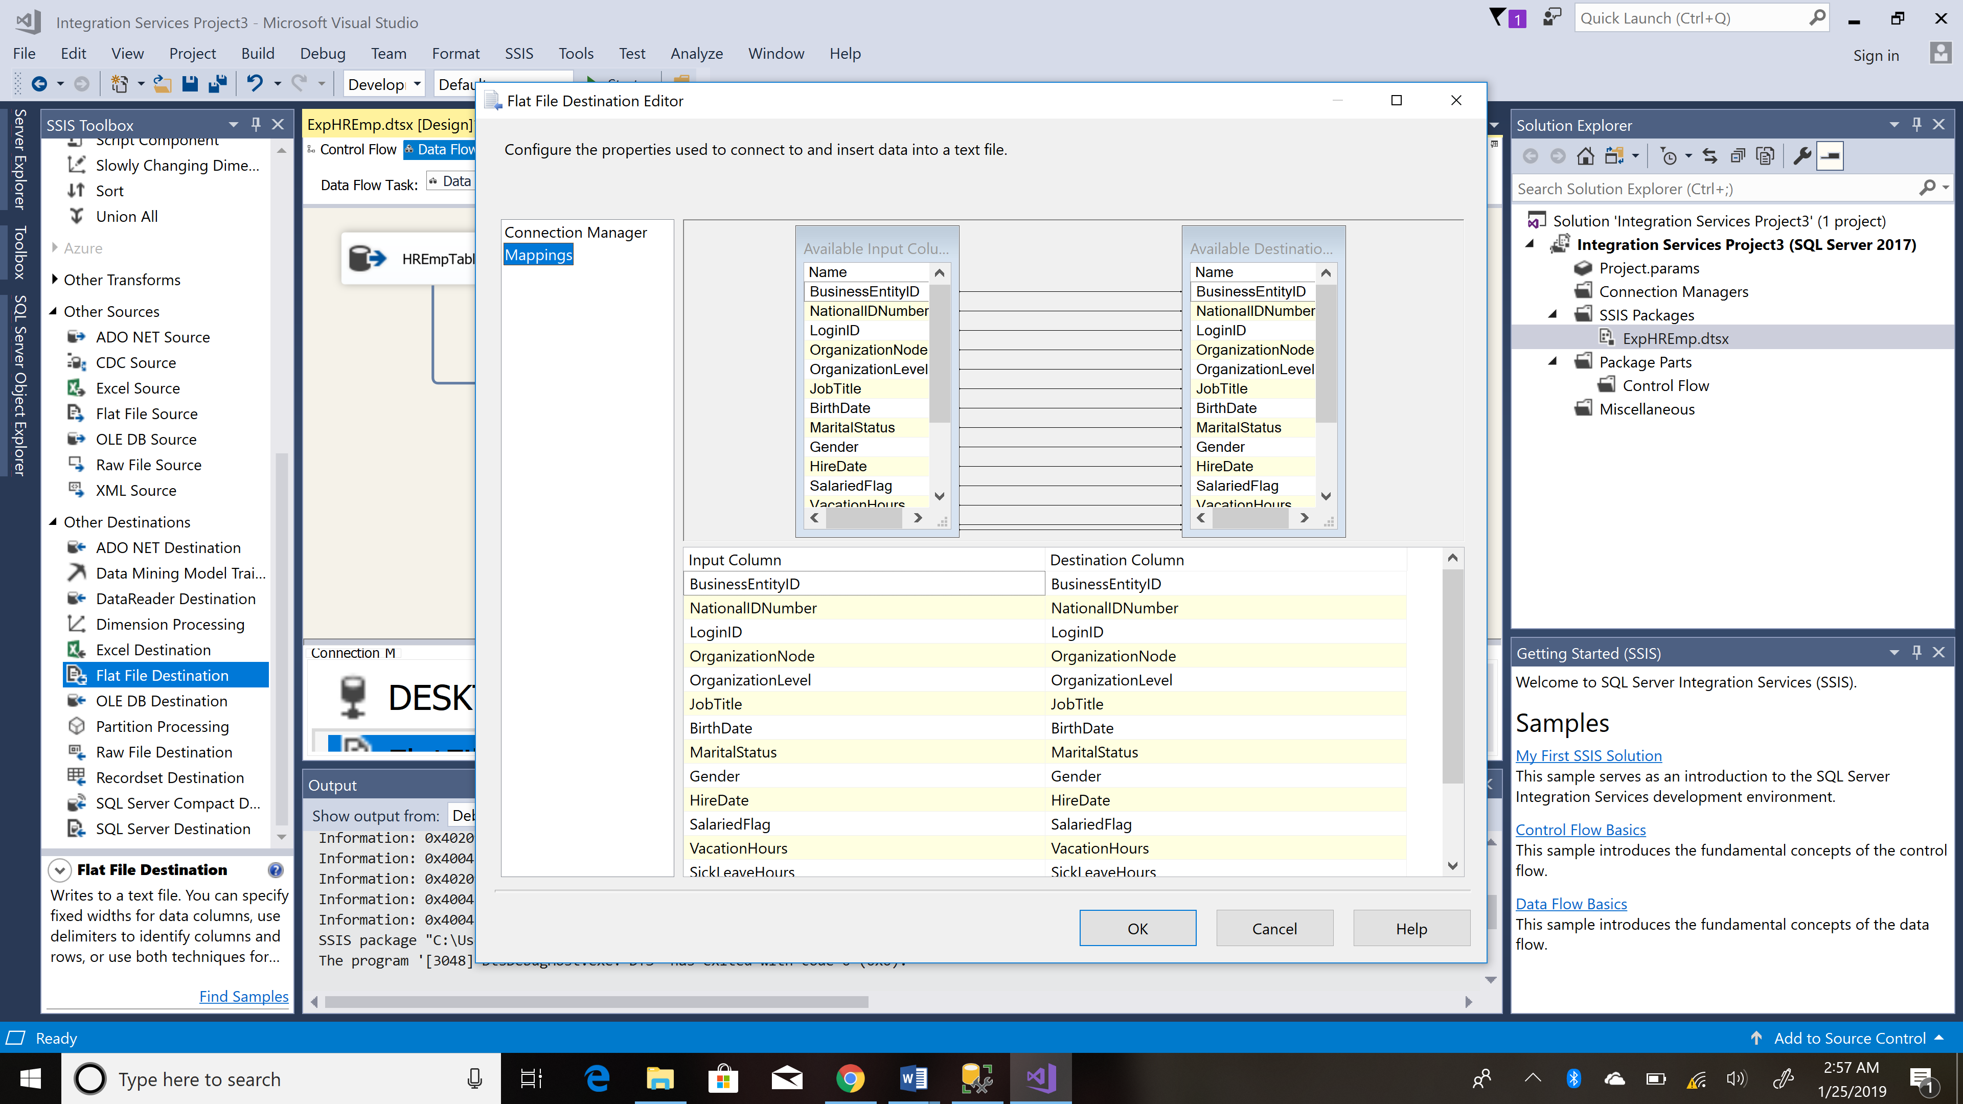

Step 4: Final SSIS package architecture for export

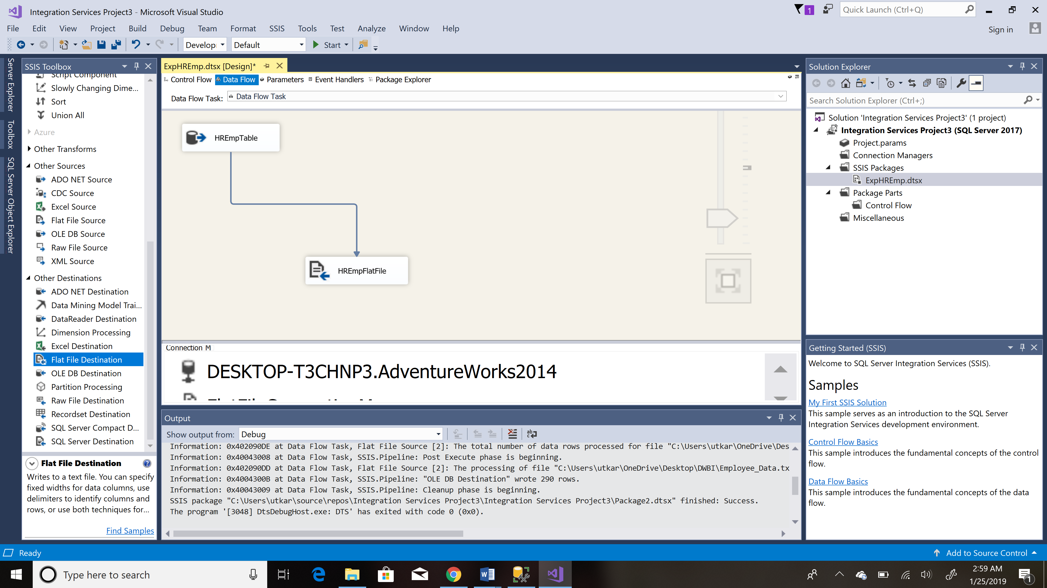

Step 5: Execution:

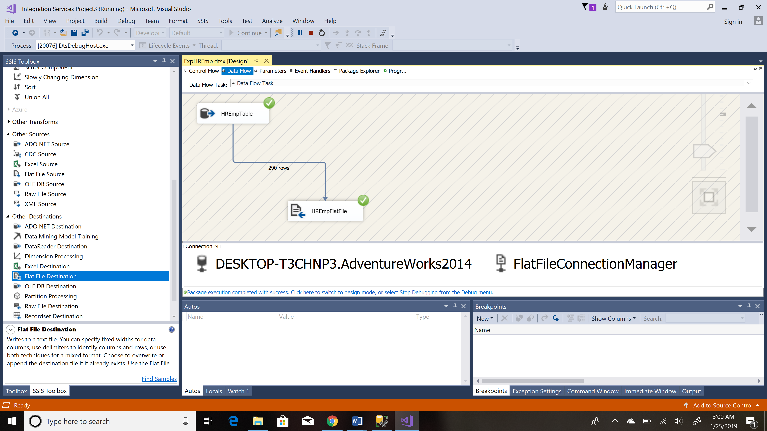

Step 6: Data Viewer

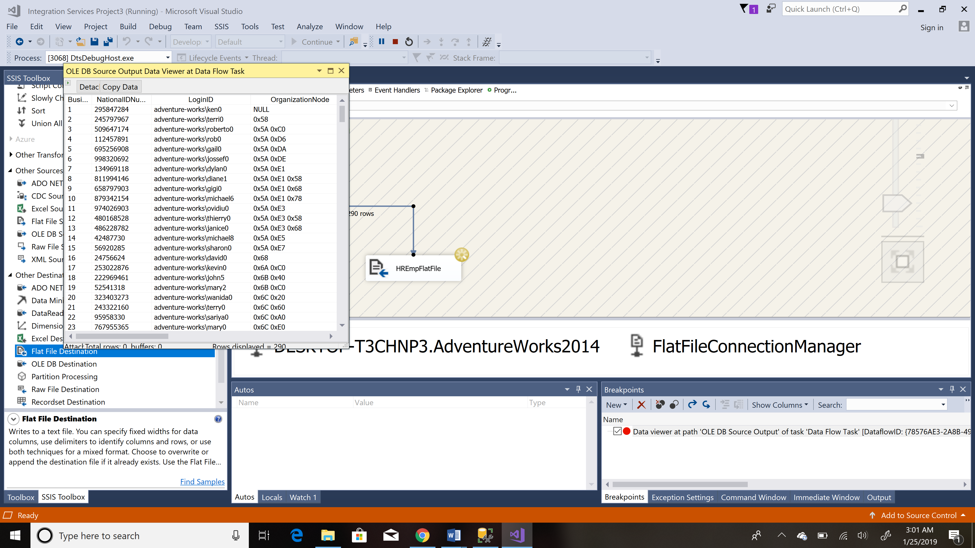

Step 7 : File got created named as : Employee_Data_HR

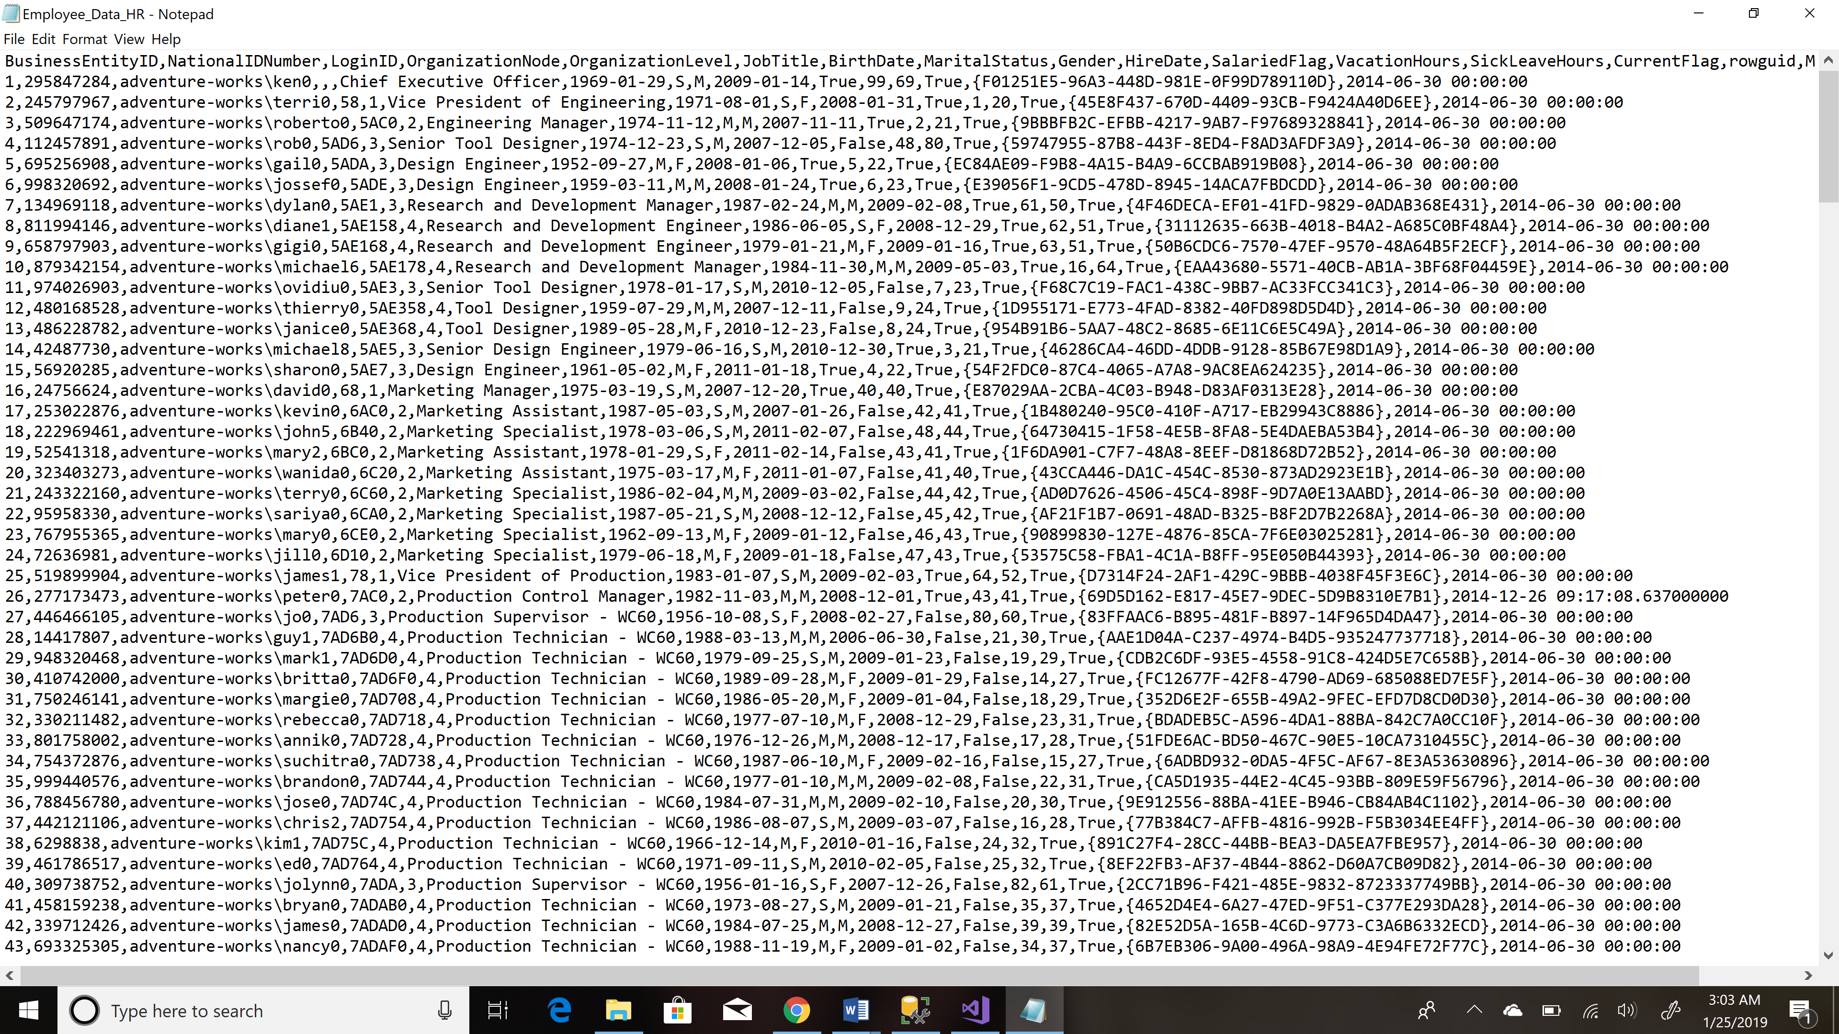

**Question 2**

Create a script for staging table for importing the employee data. Remember staging tables are less restrictive.  You can use the existing table as a template but should rename it and consider the contraints and data types during the design.

Step1: Created a script for staging table considering the constraint and data types

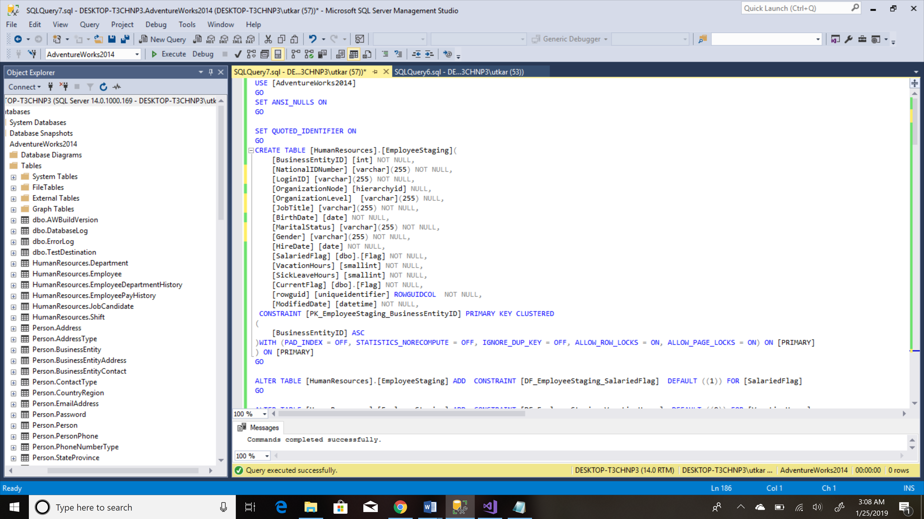

Step 2: Staging table created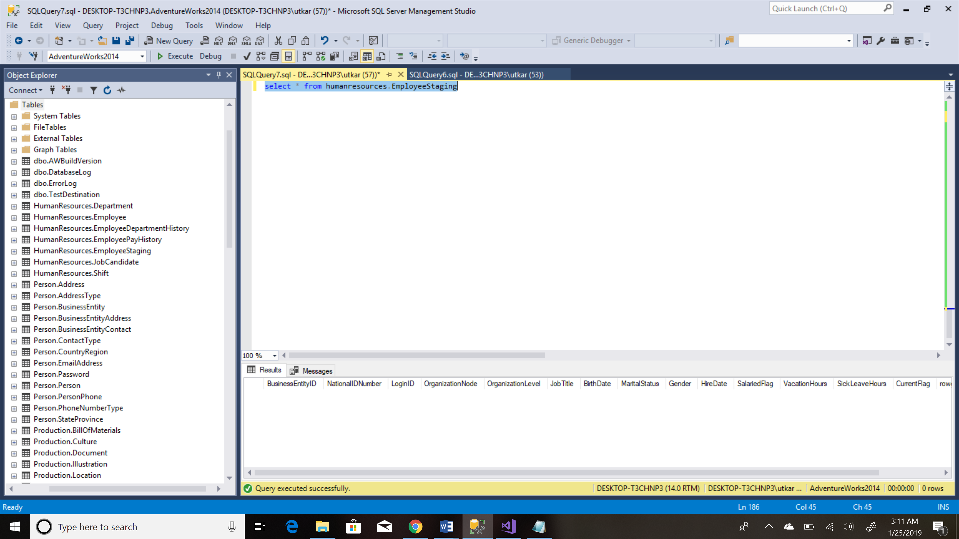

**Question 3**

Create a SSIS package to load the data. Again using the wizard to learn is fine but you need to make a package in ssis from scratch.

Step1: Data Flow Task

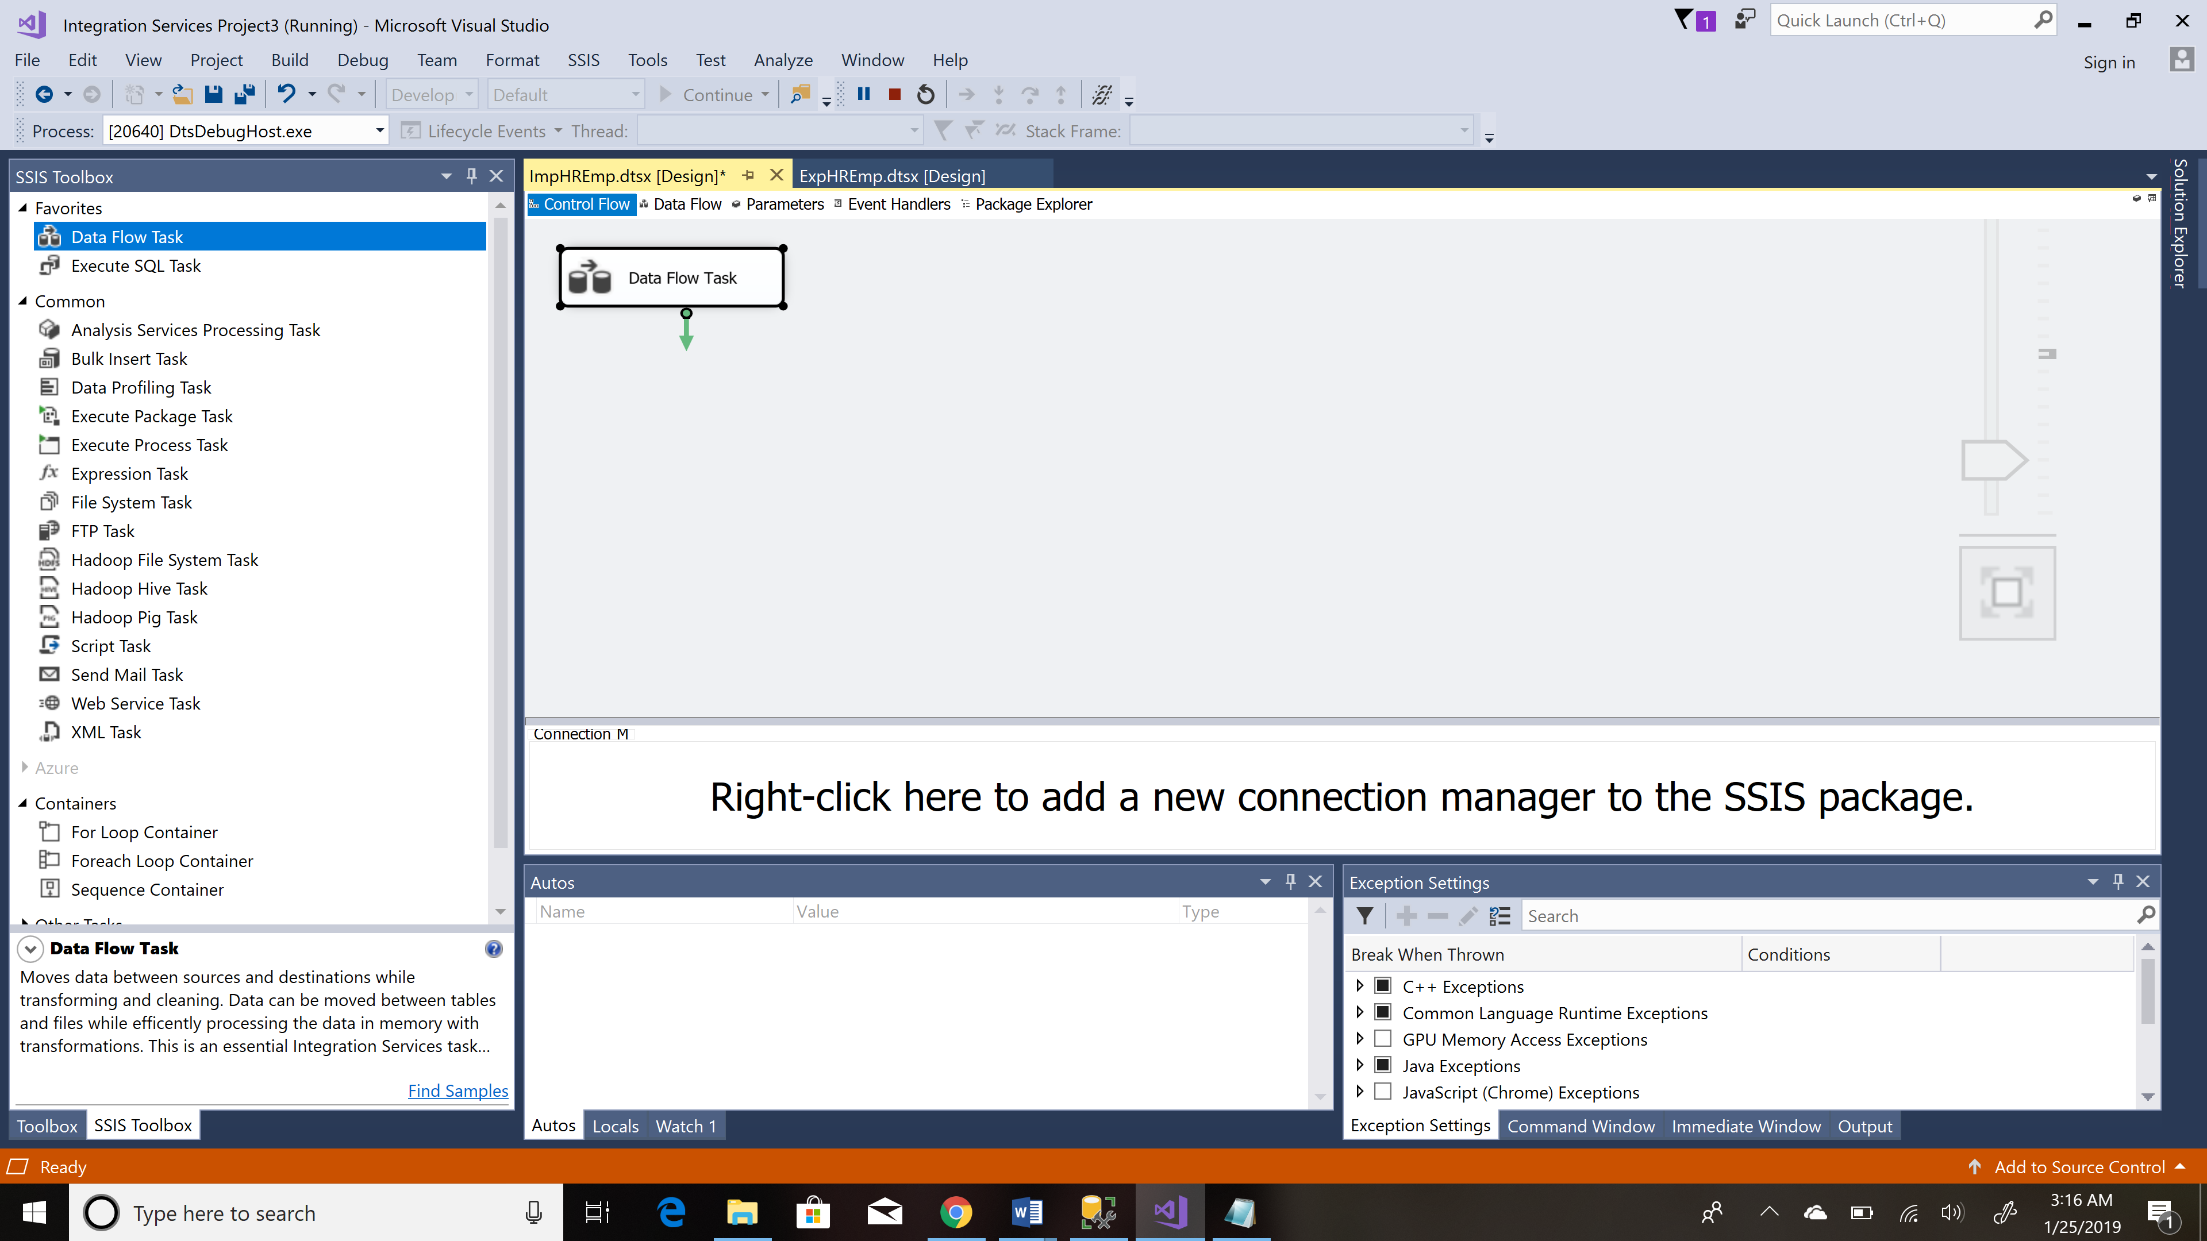

Step 2: Creating Flat File Source to Import data

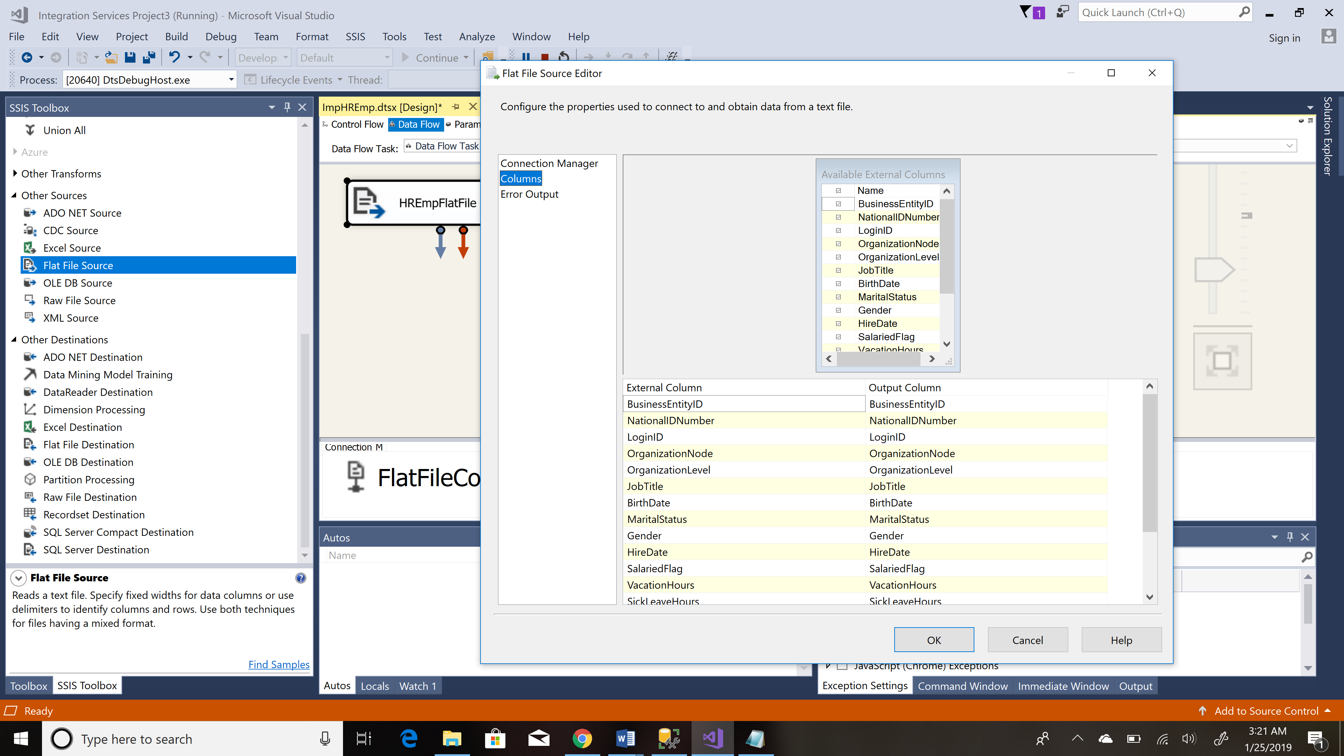

Step 3:Creating OLEDB Destination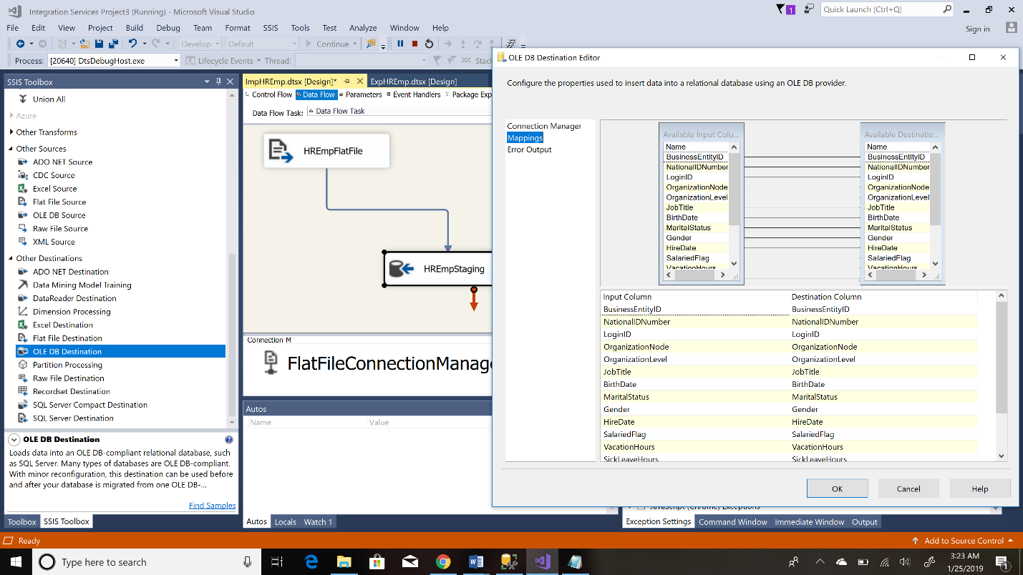

Step 4: Source and Destination created, edited and mapped

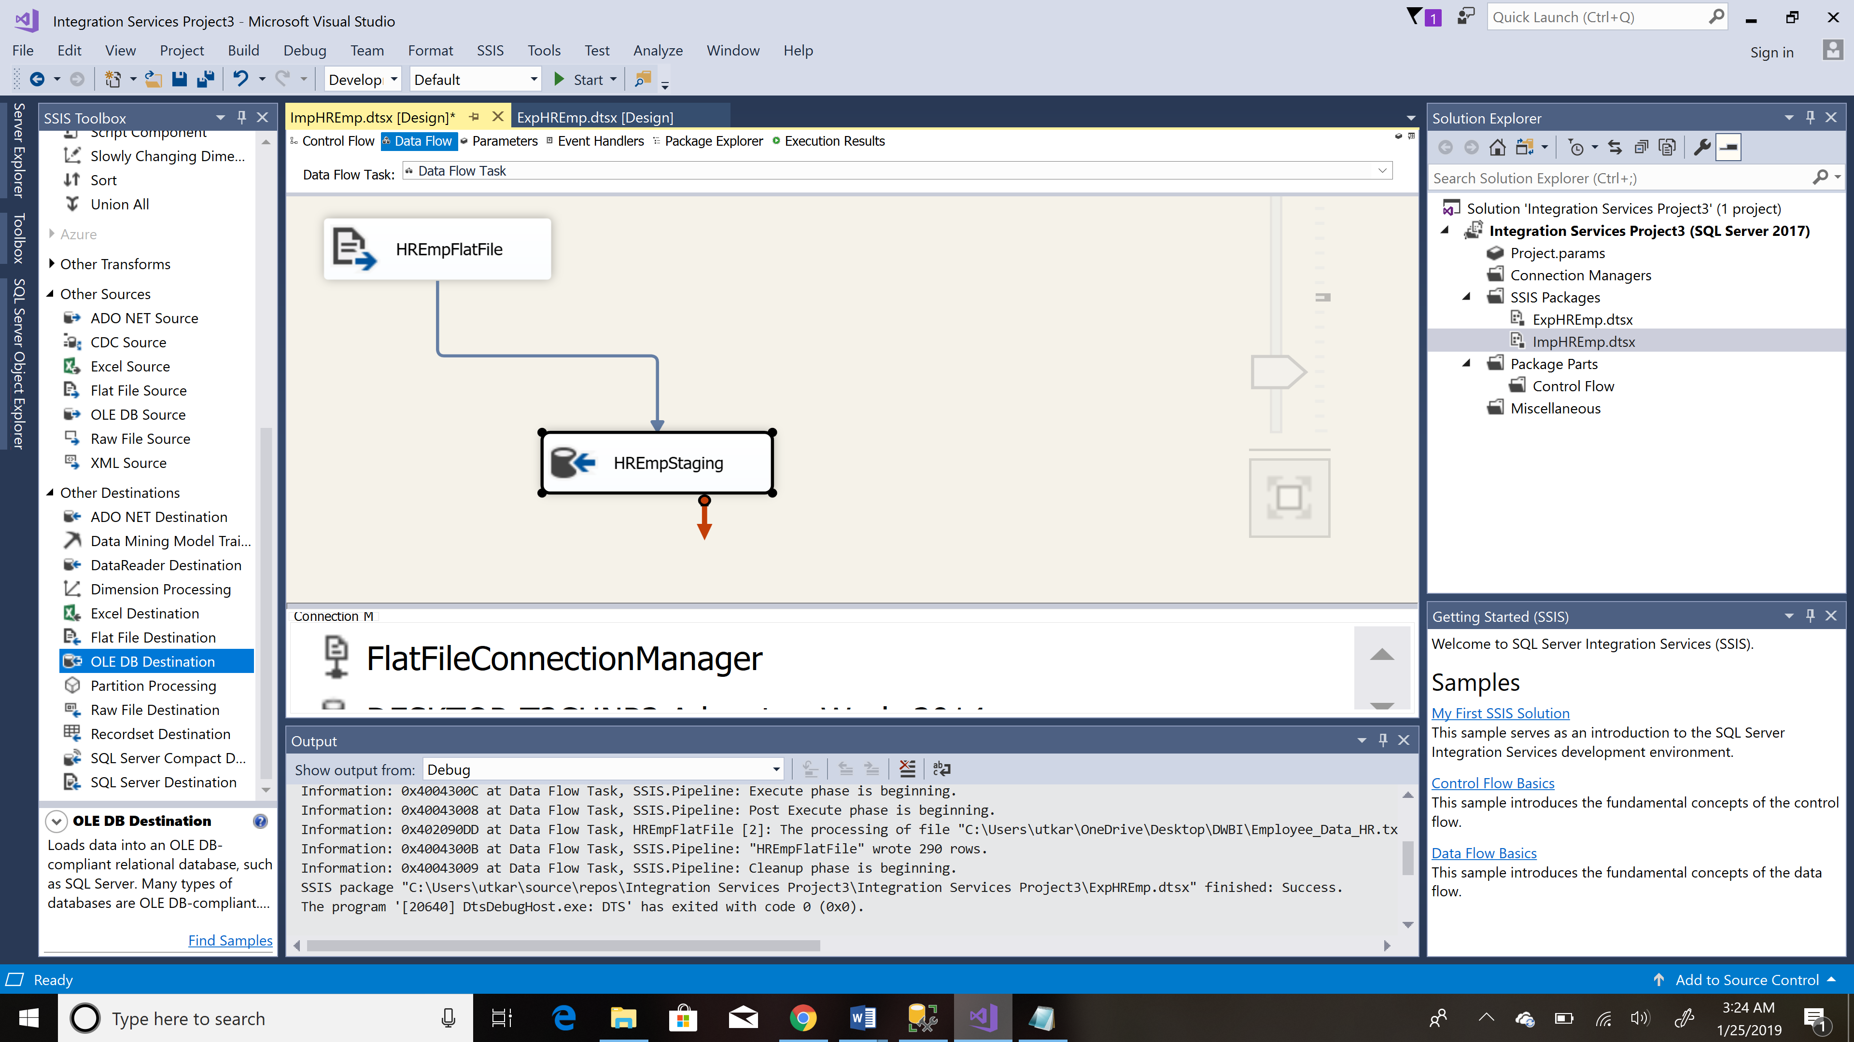

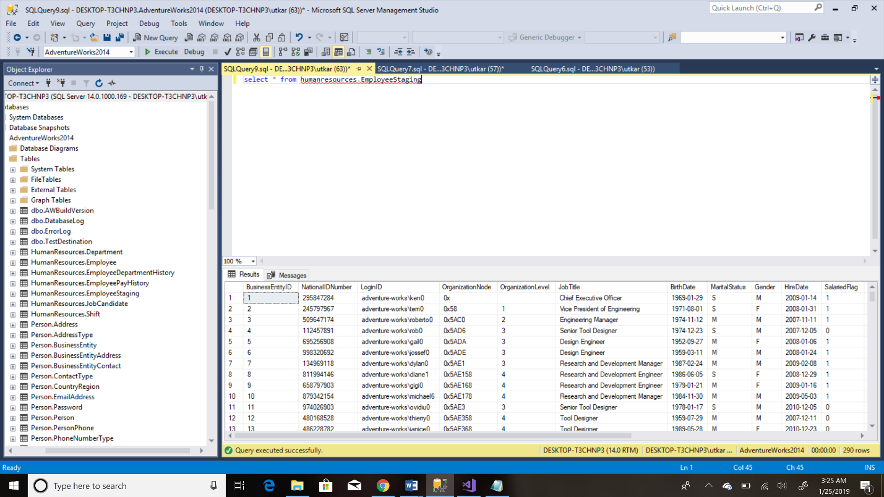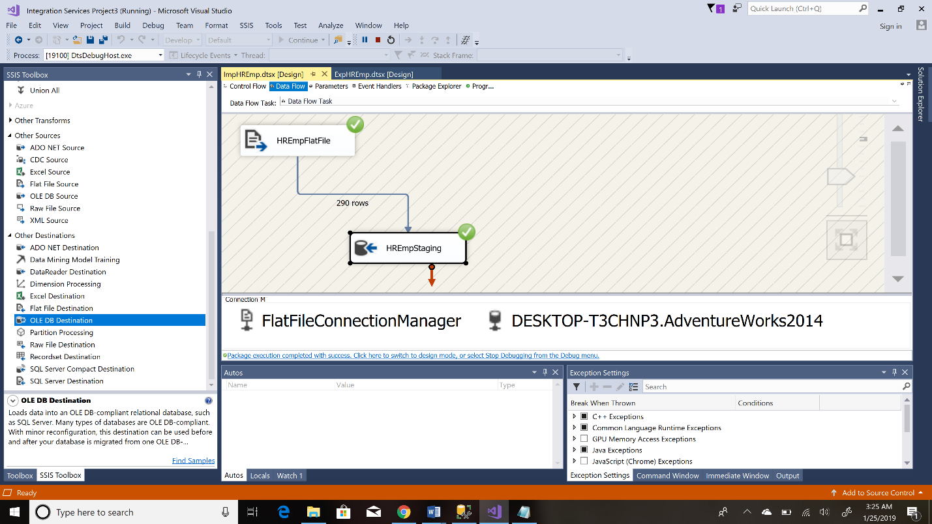Step 5: Executing the package

Step 6: Data has been imported into the table